Make sure to start the setup for AWS Sandbox if you haven’t! See below in this doc as I yap about the what and why of Cloud Computing
Microsoft Word - AWS and Fannie Mae Press Release_FINAL
Cool lil press release on FNMA’s migration to AWS

FNMA AWS Sandbox Setup
- The FNMA Sandbox is an internally-managed sandbox environment that lets you quickly and safely spin up AWS services. It’s a great way to deploy something and test it out before actually deploying stuff on “real” AWS. It has budget thresholds that will close your sandbox connection before you accidentally cost FNMA millions.
  - Some FNMA training alumni let me know that they actually use the FNMA sandbox pretty regularly. Pretty cool that FNMA set this up, it’s the first client I’ve worked with that has something like this.

Connecting to the AWS Sandbox was pretty easy, so we should be good to go for next week. I followed this: Onboarding Innovation Sandbox - steps - AWS Cloud Engineering Services - Enterprise Confluence

-Synia already gave us and the associates access in IAG. Once you get in and request an account as the Confluence doc states, you'll eventually get an email with this info:

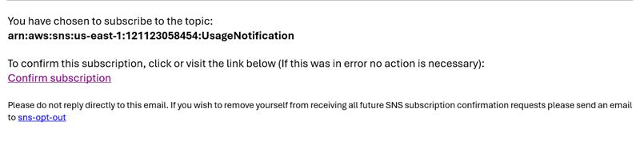

Then once you've clicked that link you SHOULD be able to access the sandbox and use AWS normally once you get this later email a few mins later:

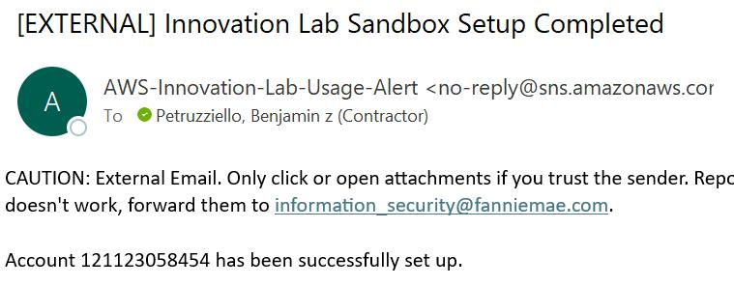

Before getting the confirmation email, you'll get an error message similar to this when you try to open the Sandbox. so just wait on it. It took me like 30 mins

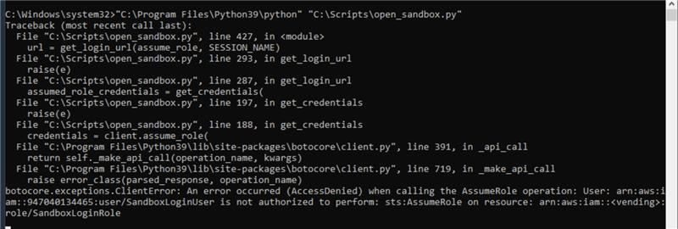

Working notes - I want to go into the sandbox relatively blind together so we can run into issues in real time. We won’t have many chances to do that. I’ll update this section as we go, or after lessons maybe.

-Note 1: No S3? :(
-Note 2: Aurora serverless w/postgres forced?
-choose endpoint (for connection in Dbeaver)
-Where’s the password?

2 Intro AWS Services we’ll see in this doc:
- RDS - Relational Database Service: Creates a virtual Relational Database.
- Creates the environment to host a database and has support for many types of databases (We’ll be using PostgreSQL). This is how a group of people can share the same database.
- S3 - Simple Storage Service: This provides object storage repositories up to 5000+ TB. Good for static data storage, and public front end deployment.

AWS RDS
(Now we can actually use Postgres instead of SQLite)
- AWS Relational Database Service is AWS’s cloud database service.
- An RDS is basically just a remote server, stripped down to focus on DBs. AWS creates the environment to host your database on the cloud, which we need if we want to host a full stack application.
- Remote DBs are also very handy for group projects, when you all need to work on the same set of data without worrying about keeping the data in sync between teammates.

- You can choose from pretty much any mainstream SQL dialect, as well as some “serverless” ones with extremely light configuration options so you can get up and running quickly.

AWS S3
- Amazon Simple Storage Service (S3) is an object storage service known for its high scalability, durability, security and performance.
- Data is stored in “buckets” as individual objects
- Just like a bucket can store different unassorted objects, an S3 bucket can store different objects of unassorted data
- I like S3s for front end deployment (and EC2s for backend deployment, which we’ll see later)
- It can also be used for backup storage, data archival, or as an intermediary in large-scale data migrations

- You can store almost any kind of file in an S3. We’re going to see basic Static website hosting with a simple HTML file, and your projects will ideally have a publicly hosted Angular app.

FNMA-Agnostic Setup ---------------------------------------------------------------
(again, we’re just using the Sandbox which is supposedly easier. So this is just here in case you need to do stuff like this later and my notes come in handy. We won’t do them together.)

RDS Setup and Connection
- Log into AWS and find RDS in services -> database -> RDS (or search for RDS)
- From the dashboard, go to DB Instances -> create database
- Select standard create to make sure we use free tier, and choose postgres
- Postgres version shouldn’t matter for free tier
- Choose free tier in templates.
- Give your instance identifier something apparent (like batch name), leave the username as postgres, and give it a password of “password”
- For instance configuration, make sure to choose db.t4g.micro, for free tier.
- In storage, choose the 20gb minimum, which we want for free tier. After 30gb across all of your AWS service they’ll start charging you. Open “Additional storage configuration” and UNCHECK AUTO SCALING! We don’t want to accidentally go over 30gb.
- Turn on public access so we can access it outside of AWS.
- Go ahead and create a new VPC security group, and give it a name. Don’t worry about specifying an availability zone.
- Click additional configuration, give your database the name postgres and turn off automatic backups, performance insights, enable encryption, and auto minor version upgrades. It CAN end up charging you if you use too much space. Everything else is fine.
- All done!!! The status will be on “creating”... and it’ll take a sec til available.

- Now we can click on our new database, and see the endpoint we’ll use to reach our database, and all the other details including the security group
- We have to CONFIGURE the security group to make sure we can access our database from our computers! Click the security group you created.
- Click the security group id, and click edit inbound rules, then click add rule IF you don’t already have a postgres rule that’s auto generated with port 5432.
- Either way - set Type to all traffic, and Source to anywhere ipv4. Save.
- Now go back to your RDS and copy the endpoint, then go to DBeaver
- Create a new postgres connection, and paste the endpoint into the Host name
- Create!!!! Note, it’s not a local database, it's a remote database! How esoteric.
- Congratulations, you have an RDS
- If it’s convenient, you can change your DB for any JDBC application to use your RDS. You’ll have to do it for P2 to share data amongst your teammates.
- Note - you can’t see what’s in your database from AWS. That’s what you’ll need DBeaver for.

*Now we have a remote database that anyone with the endpoint and password can access and change!!

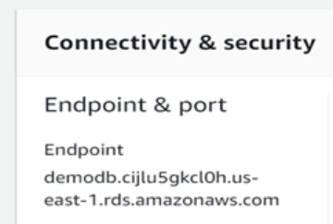
Local DB on top, Remote DB on bottom. Behaves exactly the same, but the remote one can be used for public hosting and an easily-shared DB for your team.
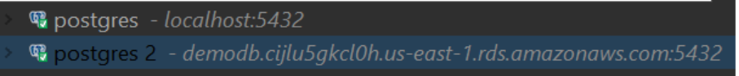

S3 Setup with a publicly deployed html page
- Search for S3, click “create bucket” and launch a new bucket. Keep all defaults EXCEPT:
- Name your bucket: At least a somewhat descriptive name
- UNCHECK “Block all public access”: We need a public bucket for public access to our hosted front end
- Create!
- Drag or upload your HTML file into the bucket
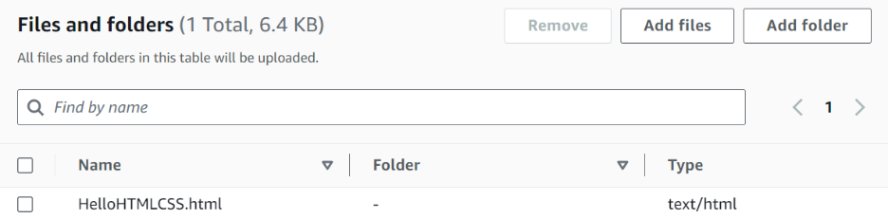
- Click “upload”
- Enable static website hosting: Click into your bucket’s dashboard, go to properties, and scroll to the bottom. Enable static website hosting and give it the name of your HTML file.
- Save Changes!
- Finally, we need to Define Bucket Policy Settings: Navigate to “Permissions”, and paste the following into the bucket policy window, making sure to change the bucket name to your bucket’s name:
{
"Statement": [
{
"Sid": "PublicReadGetObject",
"Effect": "Allow",
"Principal": "*",
"Action": "s3:GetObject",
"Resource": "arn:aws:s3:::YOUR-BUCKET-NAME/*"
}
]
}
- Save changes!
- Access your app: You should now be able to scroll down to the bottom of the “properties” tab to click and access your public URL!

*BUT BEN, we want to deploy more than just an HTML file!!!

Ok FINE-

Spinning up an S3 with a React app (we’ll be doing this with Angular later, which is very similar, so I wanted to use React here just for some horizon broadening)
- Deploying a React app is almost as simple as deploying a basic HTML file. The difference is what you’ll upload to the bucket, and how to create the folder we’re going to upload.
- So first, create a bucket and make it public with all the steps above...

- Package your react app: use npm run build to create the “dist” folder, which will hold your ready-to-deploy app.

- Upload the contents of the “dist” folder: After successful npm run build, you should have a “dist” folder in your project. This is what you’ll upload into your S3 bucket!
- NOTE: upload the CONTENTS, NOT THE WHOLE FOLDER:

- Specify the index.hml file in the “static website hosting” section of the “properties” tab

- You can now access your front-end app through the public URL found in the “static website hosting” section of the “properties” tab! Just like the previous HTML example.

